**Task 2**

**Evaluation**

Currently, there is no official paper with code and ranking of flowers image recommendation neural network.

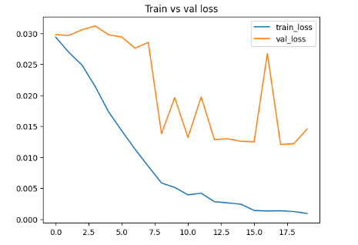**Judgement**

The metric that we use to evaluate models for task 2 is MAP (Mean Average Precision). AP tells us how well a model retrieves relevant documents for a given query. It calculates the area under the precision-recall curve. MAP is simply the average of the AP values. First, we use VGG. The MAP for VGG is 0.58. The MAP for DarkNet is 0.75. The MAP for EfficientNet is 0.67. The result of AutoEncoder is shown in Fig. 1, which is not good because the differences between train loss and test loss is quite high.

Figure 1: AutoEncoder

In conclusion, we choose DarkNet, which has 0.75 MAP score, to be our final model in task 2